Chapter 12, Problem 30.

In Fig. 12.56, the rms value of the line voltage is 208 V. Find the average power delivered to the load.

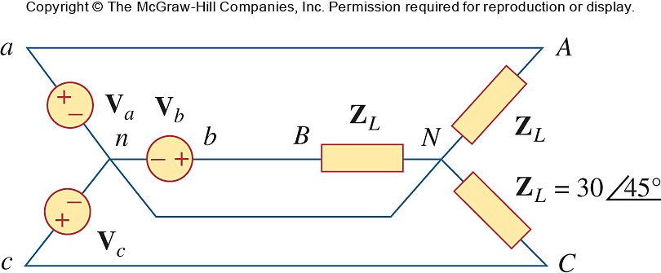

Figure 12.56
For Prob. 12.30.

